
a
Company
Logotype

Cone Beam Computed Tomography- Report



Porur Dental X-rays & CBCT

Patient Name : Mr. Rohith Kumar | Date of Report : 24.04.2025
Age/ Gender : 20 years/ Male | Region of Interest : CBCT 23
Referring doctor: Dr. Selva Ganesh | Indication : Implant assessment
Clinical Notes: Nil
PATIENT INFORMATION

CBCT- Sectional Maxilla provided
CBCT – IMAGE DETAILS

RADIOGRAPHIC INTERPRETATION

- Completely missing crown and root portion in relation to 23.
- The alveolar ridge in relation to 23 is present with normal trabecular pattern.
- Presence of a small hyperdense structure in relation to the periapical region of 22, measuring 2.33 x 2.45 x 2.12 mm in dimension, located 1.54 mm behind the apical third of 22, in the palatal cortical bone.

IMPLANT ASSESSMENT

 | 23 region
Sub-Crestal  (in mm) | 1.48
Mid- Crestal  (in mm) | 2.51
Distance between the alveolar ridge and floor of the nasal cavity  (in mm) | 17.61

RADIOGRAPHIC IMPRESSION

- Partially edentulous region: 23.
- Foreign body palatal to 22.

Kindly correlate with clinical findings


IMAGES FOR REFERENCE

RECONSTRUCTED PANORAMIC VIEW

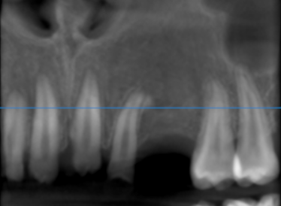

3-DIMENSIONAL VIEW

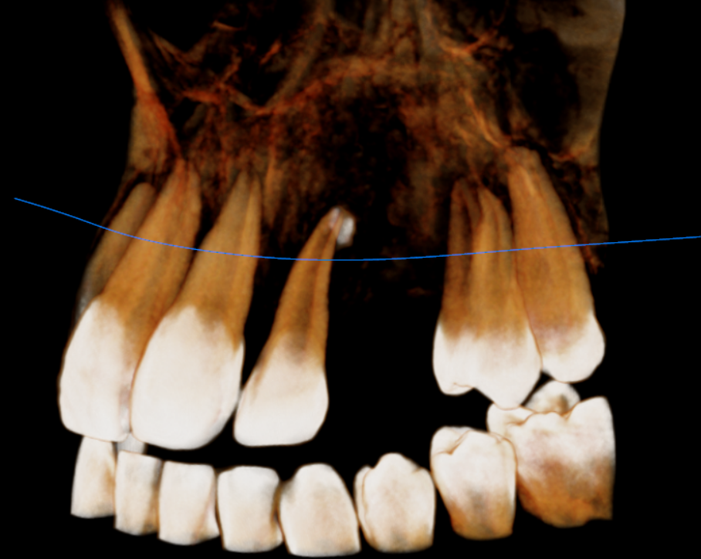

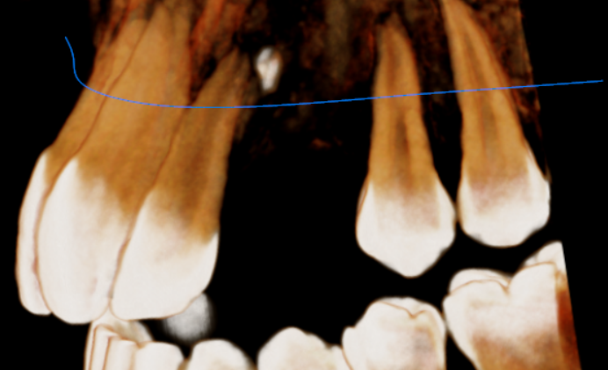
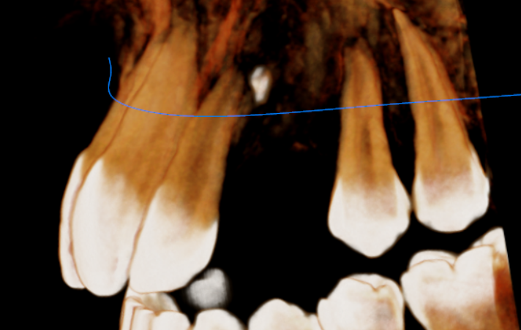

CROSS SECTIONAL VIEW

23 region | 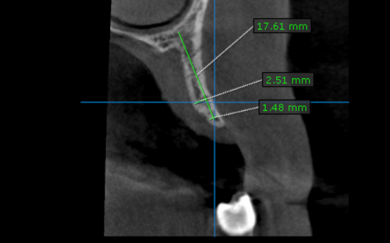
22 region | 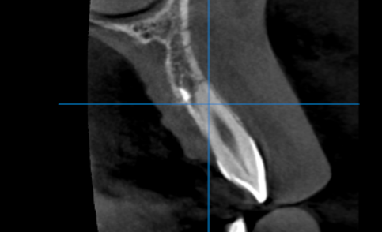

**** End of report ****

